**Django project Version 1 Notes**

Setup, Django Project Creation, Django App Creation, Run Server

---------------------------------------------------------------------------------------------

**STEP 1 - SETUP/VERIFY INSTALL**

Before installing any new software onto your computer you should verify a version doesn’t already exist on your computer!

To verify the current version of Python installed on your computer, open your CMD and type the following:

* py --version

If Python is already installed on your computer, you should see something like below:

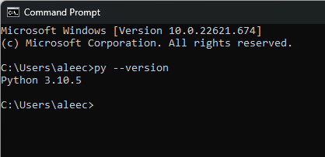

To verify the current version of Django installed on your computer, type the following in your CMD:

* python -m django --version

If Django is already installed on your computer, you should see something like below:

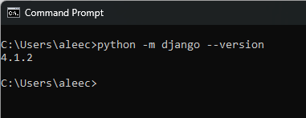

Create a new folder for your project

This can be done in a couple ways:

1. In CMD, type the following command to create a new folder:

* mkdir FolderName

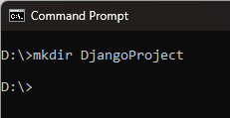

1. In your directory, create a new folder:

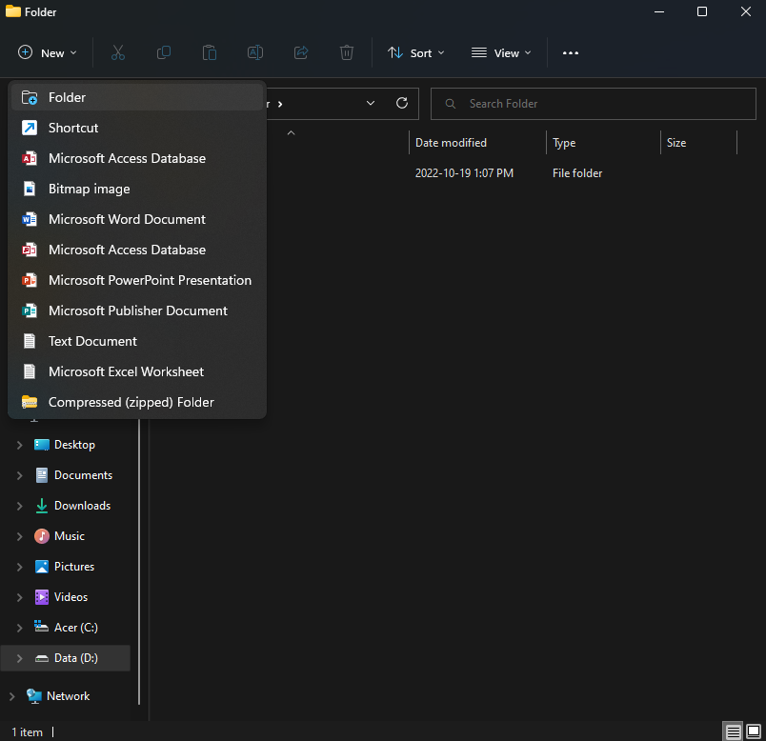

**STEP 2 - CREATE DJANGO PROJECT AND APP**

1. Open your new folder in VS Code
2. Open a new Terminal in VS Code
3. Create Python Django Project
4. Type the following into the terminal:
   1. django-admin startproject projectName .

* For this project, the project name is smartnotes
* The . indicates you want to create the project in the folder you’re currently in
* The command creates two things, a manage.py file and folder projectName
  + manage.py is entry point of the project
    - Used to run project server, manually work with the database, etc.
  + projectName folder contains files related to configuration of project
    - Two main files are urls.py (configure project’s urls) and settings.py (base of the project)

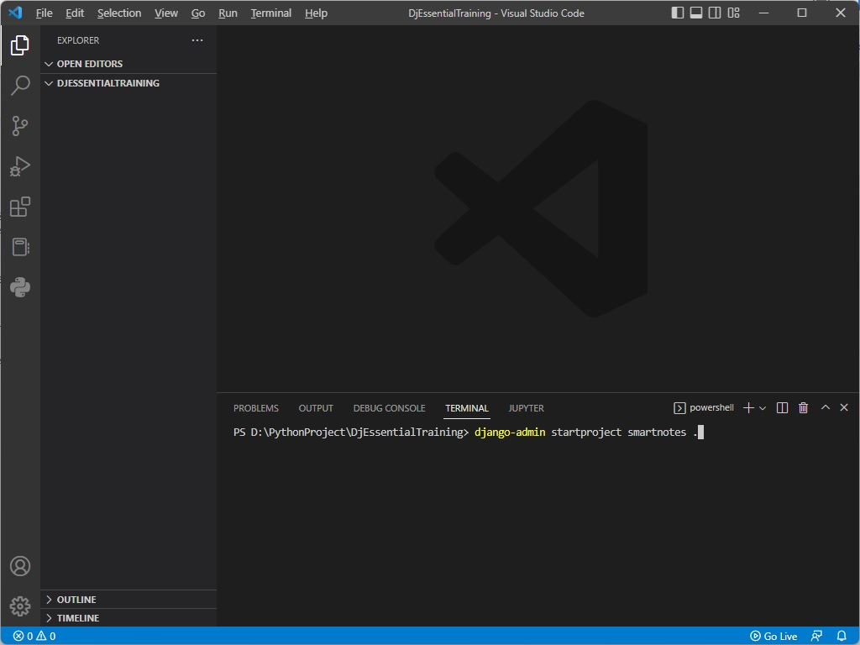

Above is what the command should look like in the terminal

Below is the result of creating a new Django Project

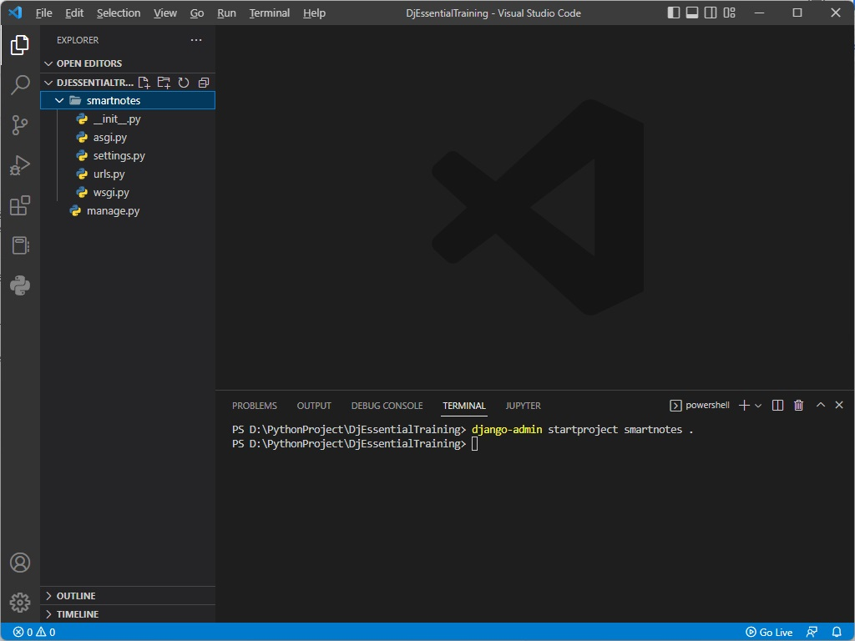

1. Run server
2. Type the following into the terminal:
   1. python manage.py runserver

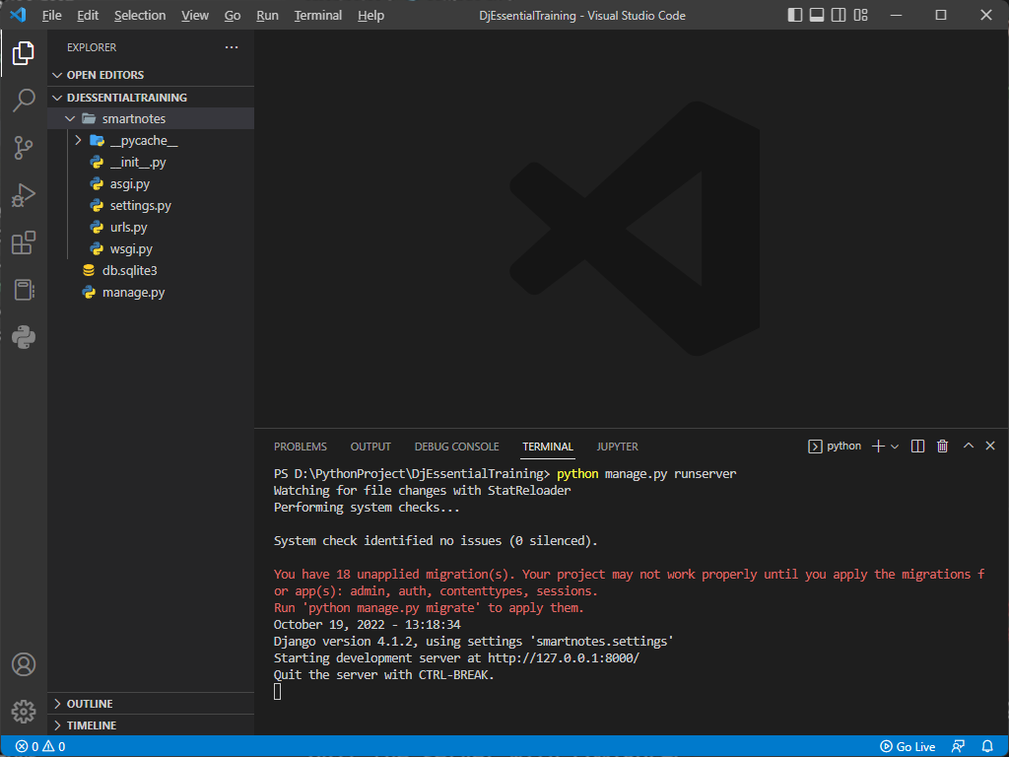

Above is what you should see in the terminal after starting the server

Below is what you should see in your browser at port 8000

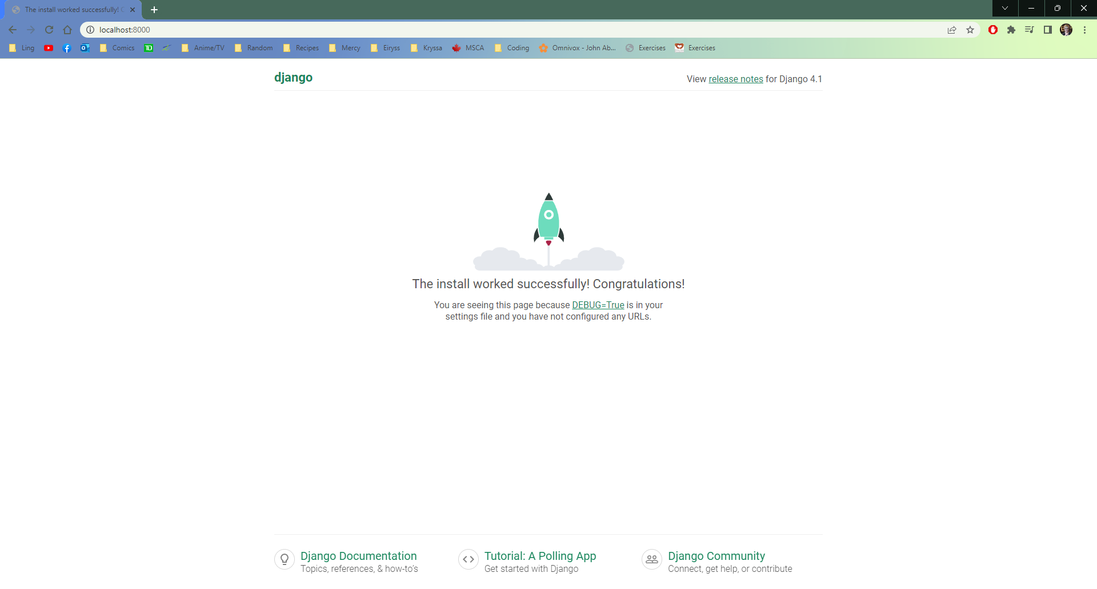

1. Create Python Django App
2. Type the following into the terminal:
   1. django-admin startapp appName

* For this project, the app’s name is home

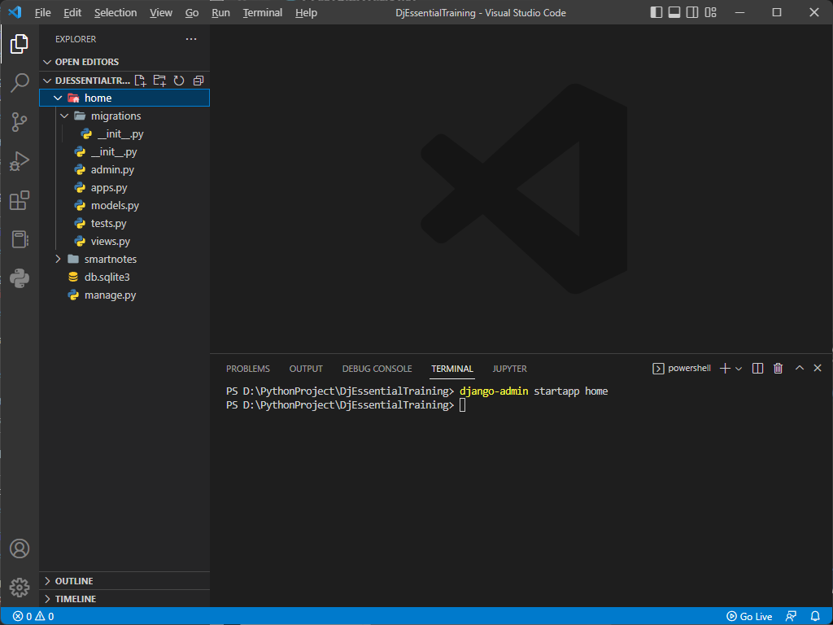

1. Go to projectName (“smartnotes”) > settings.py > INSTALLED_APPS
   1. Add the newly created app to the list of apps

